EXPERIMENT-2 BATCH FILE EXECUTION

**AIM:**

To create a Windows batch file.

**PROCEDURE:**

**Step 1 :** Open a text file, such as a Notepad or WordPad document.

**Step 2 :** Add your commands, starting with **@echo [off]**, followed by, each in a new line, **title [title of your batch script]**, **echo [first line]**, and **pause**.

**Step 3 :** Save your file with the file extension **BAT**, for example, **test.bat**.

**Step 4 :** To run your batch file, **double-click the BAT file** you just created.

**Step 5 :** To edit your batch file, **right-click the BAT file** and select **Edit**.

And here's the corresponding command window for the example above:

# 1.Create a New Text Document

A batch file simplifies repeatable computer tasks using the Windows command prompt. Below is an example of a batch file responsible for displaying some text in your command prompt. Create a new BAT file by right-clicking an empty space within a directory and selecting **New**, then **Text Document**.

# 1.CODE

Double-click this **New Text Document** to open your default text editor. Copy and paste the following code into your text entry.

**>> @echo off**

**>> echo hello**

**>> Pause**

**>> echo This is new**

**>> echo this is seconf one**

**>> pause**

# TO SAVE a BAT File

The above script echoes back the text "Welcome to batch scripting!" Save your file by heading to **File >** **Save As**, and then name your file what you'd like. End your file name with the added **BAT** extension, for example **test.bat**, and click **OK**. This will finalize the batch process. Now, double-click on your newly created batch file to activate it.

# 2.To RUN as BAT File

Once you'd saved your file, all you need to do is **double-click your BAT file**. Instantly, your web pages will open. If you'd like, you can place this file on your desktop. This will allow you to access all of your favorite websites at once.

**OUTPUT:**

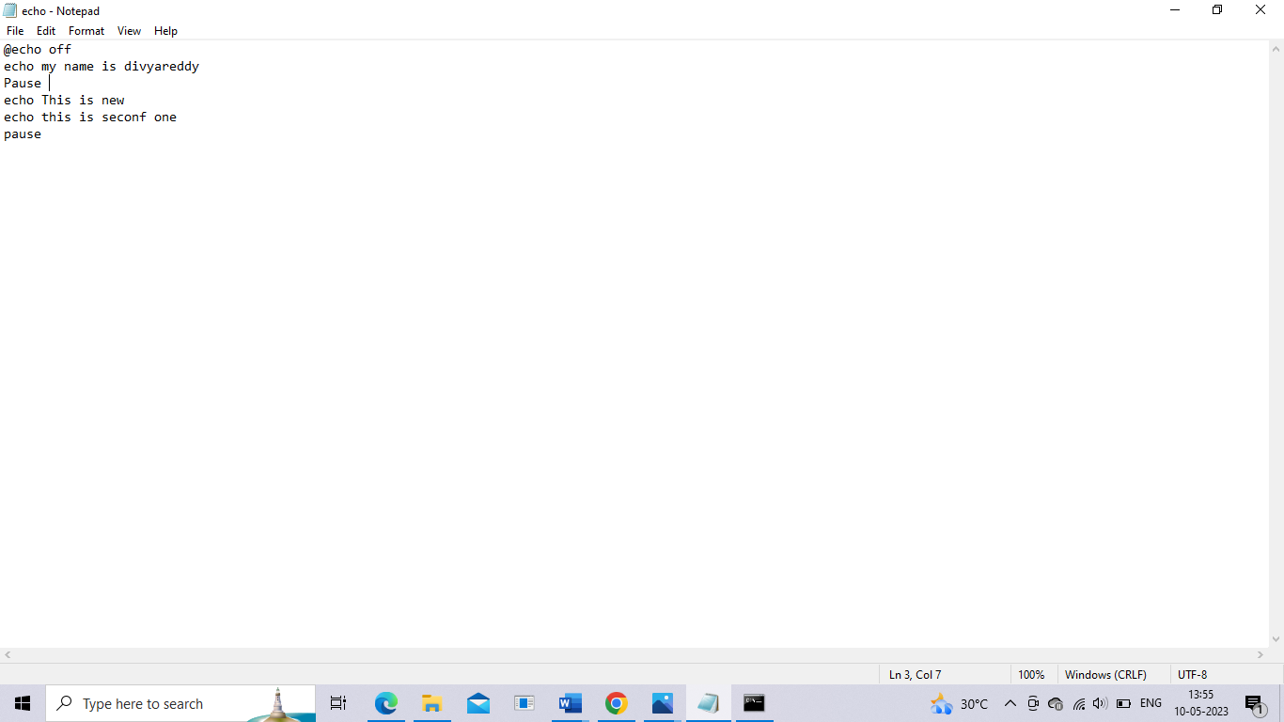



**Result**:

Hence the batch file executed successfully.